Student Name
Module 3 SLP
OPM300: Introduction to Operations Management
Professor’s Name
Date of Submission

Operations Management
Simulation is a modeling process that seeks to predict the real world outcomes of a situation by mathematically analyzing the factors involved. It is an experiment that can be used to set course of and stabilize the operations of a business in a bid to maximize profits and maintain customer loyalty.
Simulation experience
The following are the inputs used;
Run # | Tables | Parties | Meal Time
1 | 16 | 10 | 40
2 | 16 | 10 | 50
3 | 16 | 10 | 60
4 | 17 | 10 | 40
5 | 17 | 10 | 50
6 | 17 | 10 | 60

When the participant changed the meal times in Runs 1-3; from 40 minutes to 50 minutes and then to 60 minutes, the wait times increased; from 27 minutes, to 31 minutes then to 40 minutes respectively. This explains that an increase in meal time results in an increase in wait time. Therefore, customers will have to wait in the queue more to be served. On the other hand, when the participant increased the number of tables used from 16 to 17 tables in Runs 4-6, with the meal times similar to Runs 1-3, there was a significant decrease in wait times compared to that of Runs 1-3 that had a table less. This explains that an expansion of the restaurant such that more tables are added may significantly decrease the amount of time the customers will have to wait in the queue.
Solver and simulation
The first simulation carried out by the participant shows that with an arrival rate of 20 customers/unit time and a service rate of 30 customers/unit time, the number of customers in the queue will be 12. The second simulation carried out by the participant seeks to explain what would happen if the number of customers arriving at a unit time increases from 20 to 25 and the service rate increases simultaneously from 30 to 50. The maximum number of customers in the queue decreases to 11 and while server utilization probability remains the same (0.625). This explains that an increase in customer service rate by a significant amount decreases the amount the customers have to wait in the queue, even with an increase in customer arrival rate. Also, the third simulation depicts that a decrease in customer arrival rate from 20 to 15 while the services rate maintain a high trend will lead to a decreased queue length (from 12 to 5). This explains that a decreased customer arrival rate with high service rates leads to a small queues.
Understanding queuing
According to Loving et al. (2017), long queues form when there is poor customer service thus leading to customer dissatisfaction and a lower perception of value. These authors recommend a four-step framework that will help in making the queuing practices better. First, the participant should analyze the factors leading to the formation of the queue. This will enable the participant to manipulate these factors in such a way that will lead to very short queues and thus timely customer service. In the simulation runs 4-6 above, the number of tables used by customers is a factor that determines the length of the queues. Therefore, the participant increasing the number of tables leads to a significant decrease in waiting times and a consequent decrease in the queue lengths.
Second, the authors recommend improvement of the processes that are done such that they will decrease the time required to render services to the customers. In the simulations above, Runs 1-3 explain that an increase in meal time might lead to longer waiting time for customers in the queue and a consequent loss of customers. Thus, shorter meal times are better. Brief and of good quality improve the value of the business. Third, the authors recommend a reduction in variability. The final recommendation by the authors is addressing the psychology of queues.
Customers are generally impatient and therefore, trying as much as possible to decrease the queue lengths is a beneficial thing to the company. This can be done by decreasing service time or improving the quality and experience of waiting time. Liang (2019) argues that a company has the power to manipulate how customers perceive waiting time. This author recommends that by making waiting environments better, making the queuing process more enjoyable, and making promotional activities enjoyable, a company can change the perception of waiting time to seem shorter and overall customer experience better. Weiss and Tucker (2018) explain that by providing customers with timely and relevant communication, a company can manage the expectations of the customer thus decreasing the discomfort experienced in queues hence a better customer experience.
The consumer
Salman et al. (2021) argue that simulations involving customer behavior at point and time of purchase provides valuable information to managers. In their research study, these authors find out that impulse buying behavior in customers is an economic analysis that is based on the consumer-product relationship. Therefore, simulation of impulse buying behavior can predict buying patterns and improve the company’s business practices. Zhang and Zheng (2019) argue that through simulation, companies can predict the effects of different product quality, product price and promotions strategy on consumer behavior. Simulations are also used to predict performances of economies that are yet to be implemented. Michael et al. (2017) argue that simulation helps decision makers in determining the effect of introducing circular economy/business models.

Conclusion
In conclusion, simulation is a key tool that helps predict the effects of different strategies, activities and even disasters in the real world. This aids in managing the possible outcomes in a better way.

References
Liang, C. C. (2019). Enjoyable queuing and waiting time. Time & Society, 28(2), 543-566. https://journals.sagepub.com/doi/abs/10.1177/0961463X17702164
Lieder, M., Asif, F. M., & Rashid, A. (2017). Towards Circular Economy implementation: an agent-based simulation approach for business model changes. Autonomous Agents and Multi-Agent Systems, 31(6), 1377-1402. https://link.springer.com/article/10.1007/s10458-017-9365-9
Loving, V. A., Ellis, R. L., Rippee, R., Steele, J. R., Schomer, D. F., & Shoemaker, S. (2017). Time is not on our side: how radiology practices should manage customer queues. Journal of the American College of Radiology, 14(11), 1481-1488. https://www.sciencedirect.com/science/article/pii/S1546144017306853
Siar, S. A., Keramati, M., & Motadel, M. (2021). Agent-Based Simulation of Consumer Behavior in Impulse Buying. Journal of Industrial Management Studies, 19(62), 99-138. http://journals.atu.ac.ir/article_13160_0ac21170e2048d7bf40e9fb599b7e3f8.pdf
Weiss, E. N., & Tucker, C. (2018). Queue management: Elimination, expectation, and enhancement. Business Horizons, 61(5), 671-678. https://www.sciencedirect.com/science/article/pii/S0007681318300727
Zhang, N., & Zheng, X. (2019). Agent-based simulation of consumer purchase behaviour based on quality, price and promotion. Enterprise Information Systems, 13(10), 1427-1441. https://www.tandfonline.com/doi/abs/10.1080/17517575.2019.1654133

Appendix A
M/M/1 Solver & Simulator: Run #1
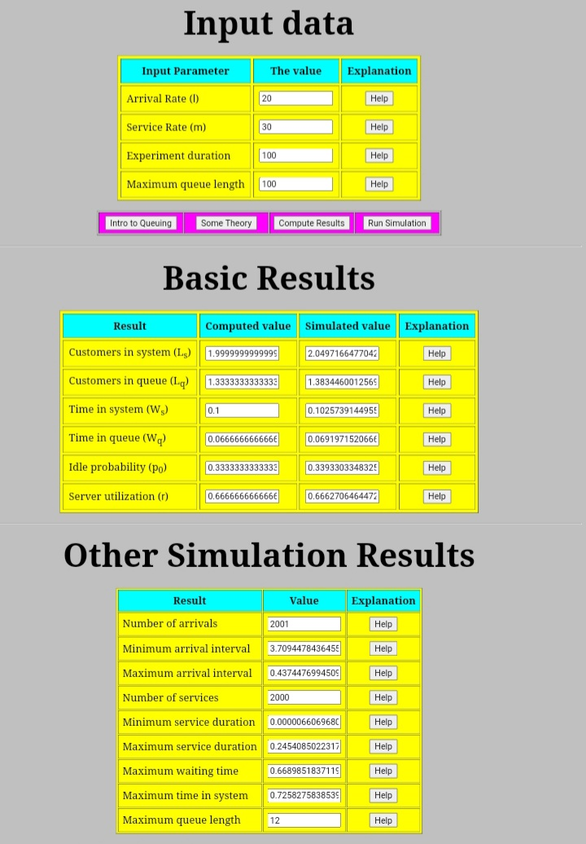
Appendix B
M/M/1 Solver & Simulator: Run #2
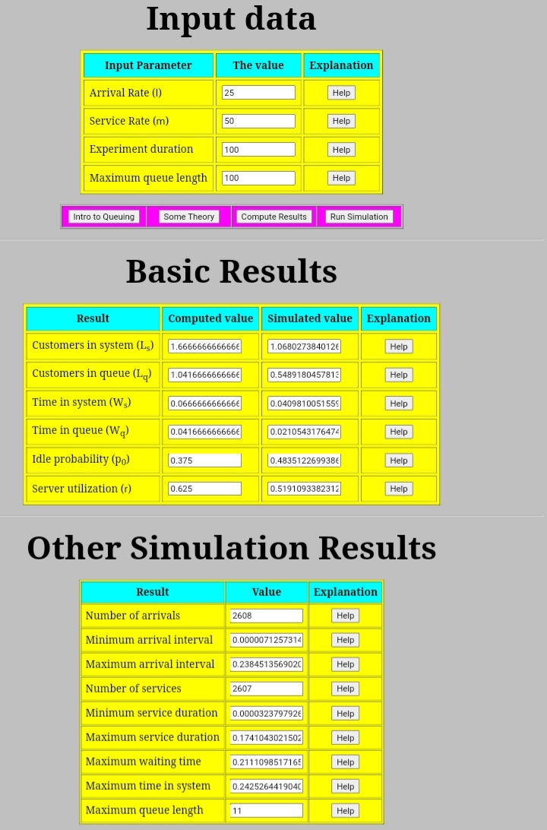
Appendix C
M/M/1 Solver & Simulator: Run #3
